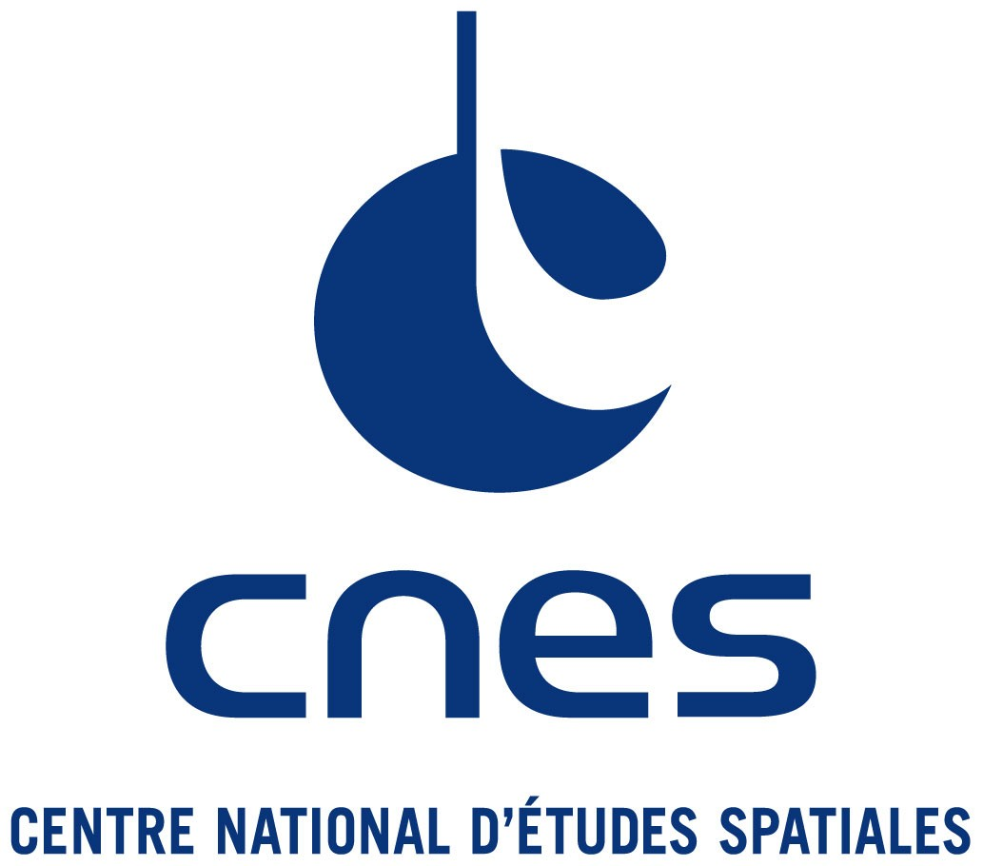

User Licence for the DTM software

DESCRIPTION OF THE DTM SOFTWARE

The DTM software (Drag Temperature Model) has been developed and is constantly maintained by the Space Geodesy Office of CNES (Centre National d'Etudes Spatiales). It is made up of Fortran code and files that contain the model coefficients. The model predicts neutral temperature, partial and total density, point wise, in the altitude range 120-1500 km.
Solar and geomagnetic proxies are used to drive the model, the procurement of which must be done by the licensee.

For this software, which is the property of CNES, CNES grants to the Licensee a free non-exclusive licence.

LANGUAGE OF THE CONTRACT
The present licence is established in English.

DURATION
The duration of the present licence is three (3) years, renewable on request.

GRANTED RIGHTS
CNES grants to the Licensee a non-paying right of use of the DTM software in its original version in source code and of the associated model reports. If produced during the licence duration, model updates will also be available to the licensee.
The above rights are granted to the Licensee on the strict conditions:
- That the CNES copyright be maintained and that the present licence be mentioned on each copy of the original DTM software and its associated documentation;
- That the Licensee does not use the DTM software in a manner that would harm CNES's public image, in particular its technical and scientific reputation;
- That the Licensee mentions CNES's DTM software in every article or presentation that uses results based on its use.
- The use of DTM software is allowed for research and specific operational use (including work under your project). Any other commercial or non-commercial use is strictly prohibited.

Should the Licensee not fulfil one of these conditions, he would become an illegitimate user and could therefore be sued for infringement. Legal action is brought before the International Court of Arbitration of the International Chamber of Commerce in Paris.

WARRANTY
The Licensee will use the DTM software in its present state at his own risk, without any guarantee of any kind from CNES. CNES has no commitment to correct any anomaly or other deficiencies whatsoever of the DTM software. Any guarantee, whatever its implicit or explicit conditions, guarantee against infringement in particular, is hereby excluded. CNES cannot be held liable for any damage for the Licensee that can result from the use of the DTM software. In the same manner, CNES cannot be held liable for any loss of income or profit, or any direct or indirect damage that can result from the use of the DTM software or its ineffectiveness, even in the case where CNES would have been warned of the possibility of such damage.
The use of the DTM software constitutes an implicit acceptation by the user of the terms of the present licence.

Date and signature of the Licensee ?? ?? 202x,

Signed by (Print name) ) __Sean Bruinsma_____________

For and on behalf of ) ___________________________
Your institute/company

Job Title ) ___________________________

Date ) ___________________________

